

Network Security

Assignment 4

Soheil Shirvani 3720505



1. Find the IP range, number of valid host machines, and the subnet mask of a network 192.168.1.0/28

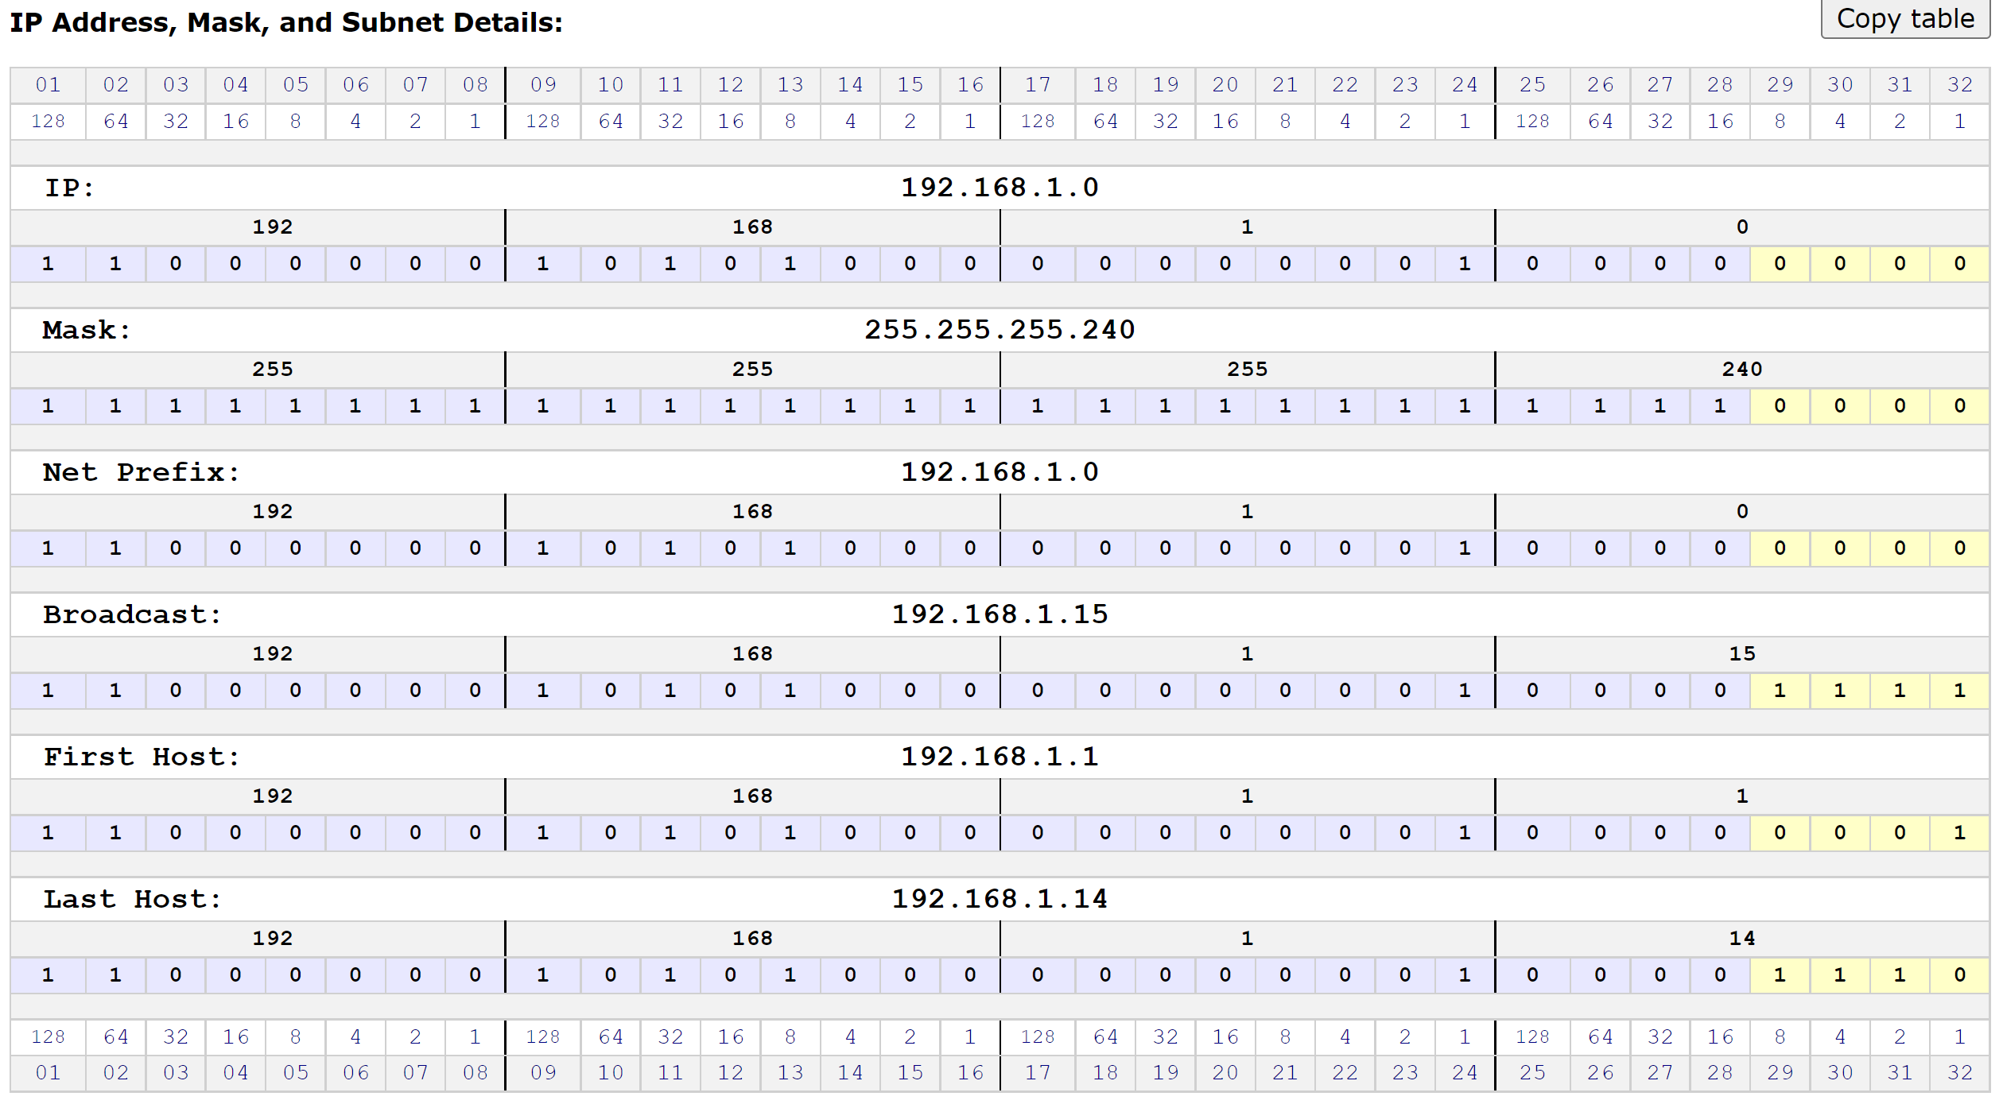

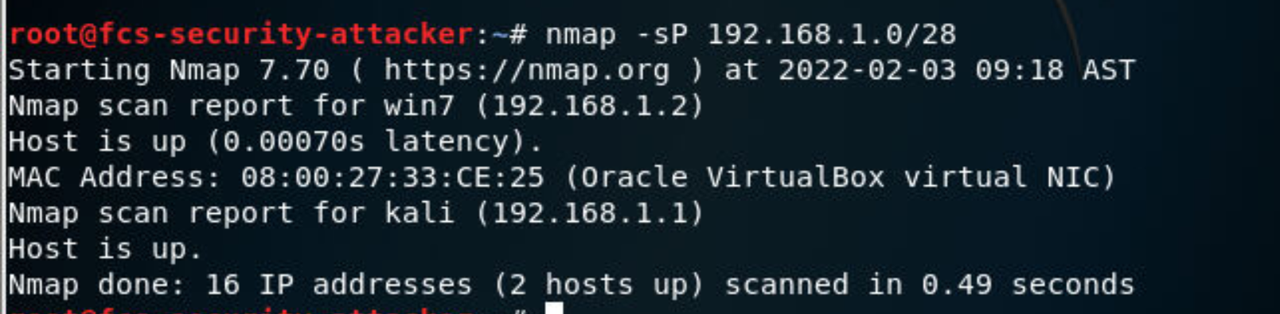

Found 16 IP addresses in which 2 hosts are up

1. 2) Find the IP range, number of valid host machines, and the subnet mask of a network 192.168.1.0/23

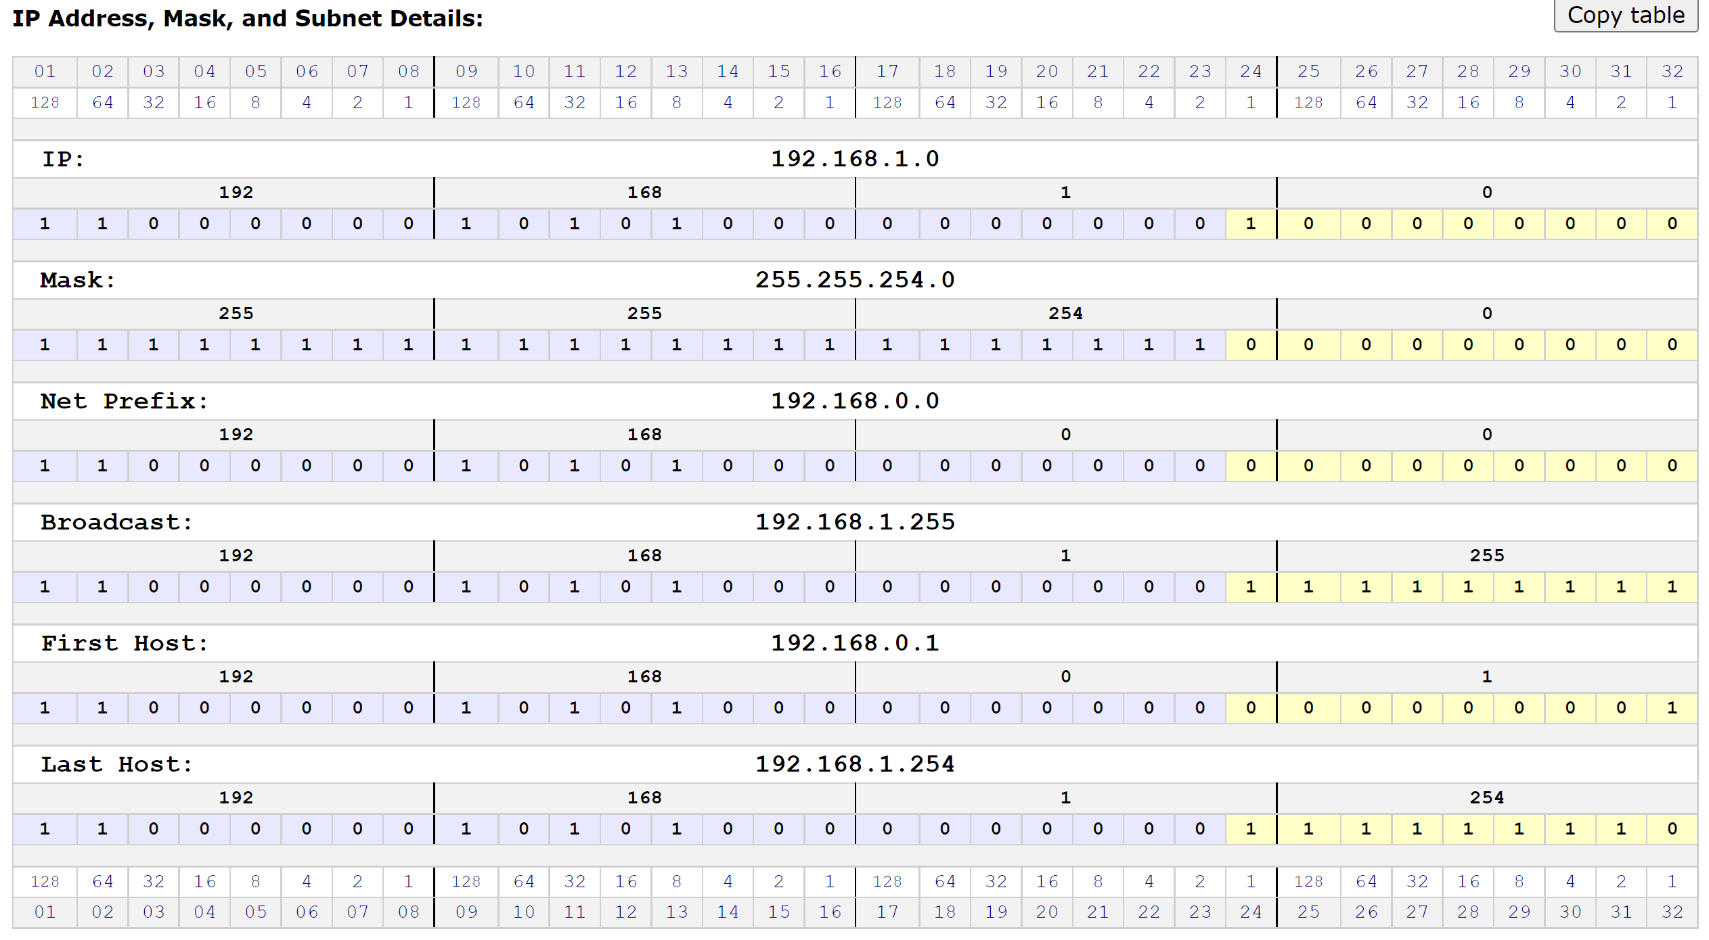

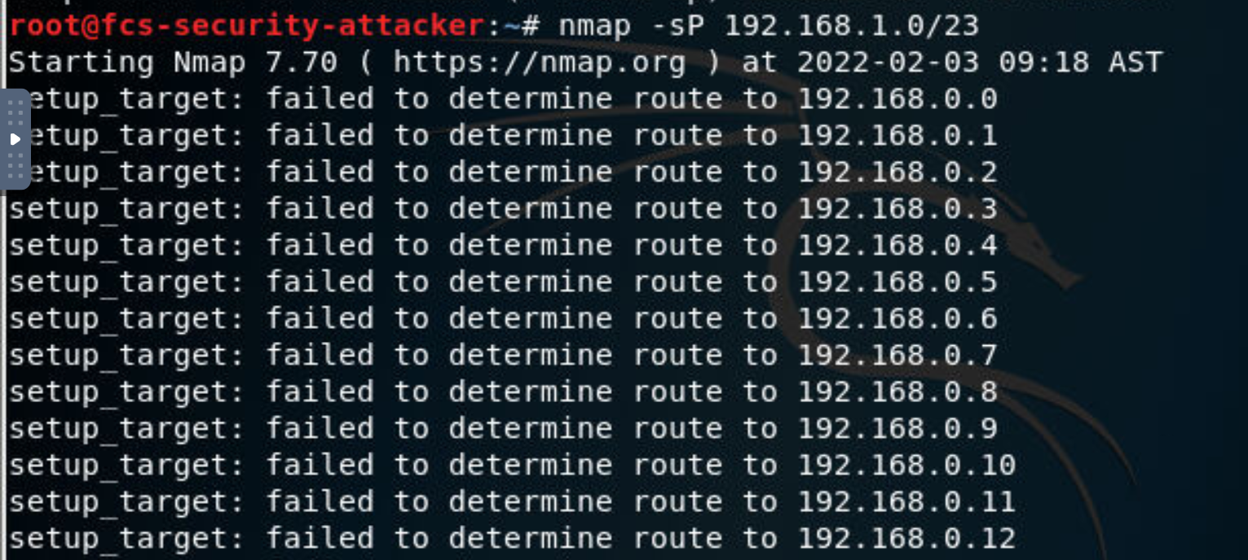

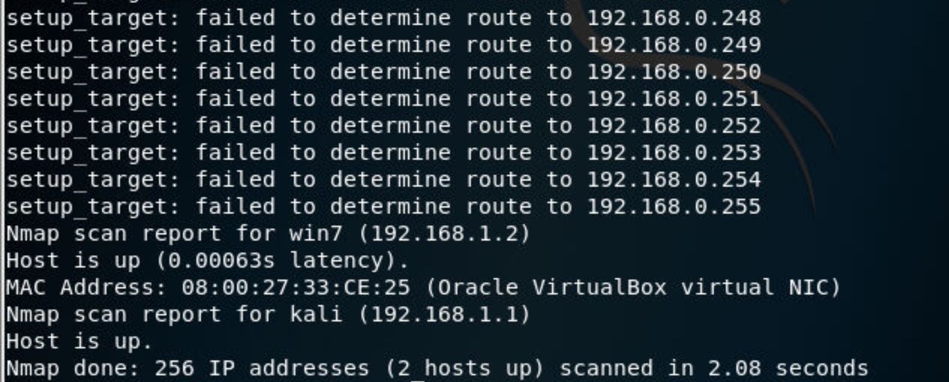

Found 256 IP addresses in which 2 hosts are up (Attacker and Victim VMs)

1. Suggest a CIDR block for IP address 192.168.1.0 to support up to 62 active nodes in the network.

To find 64 host:

<https://wintelguy.com/ip-mask-visualizer.pl>

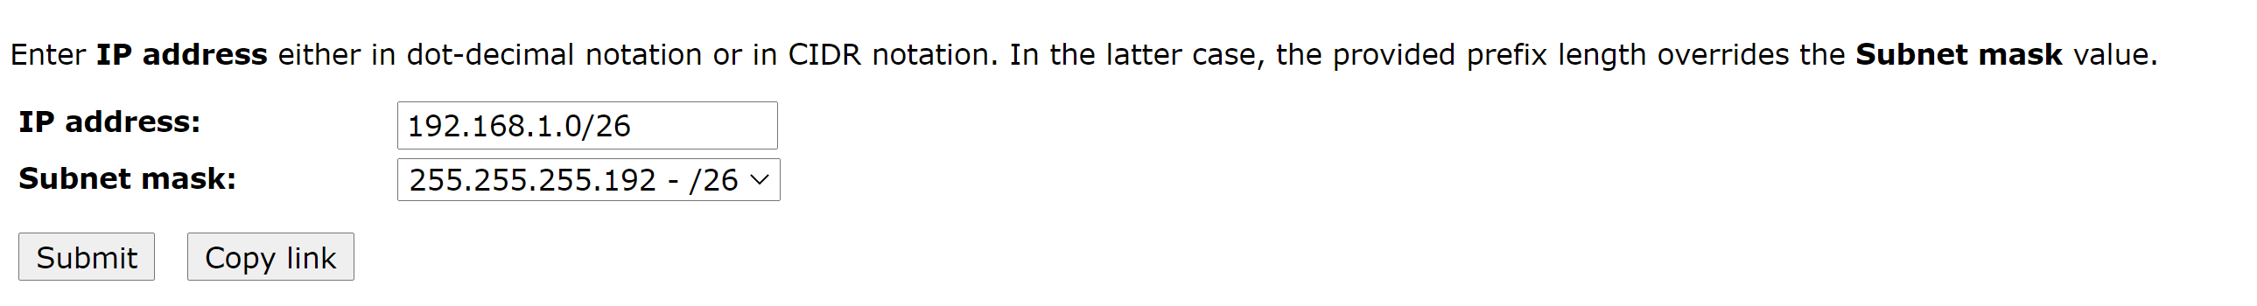

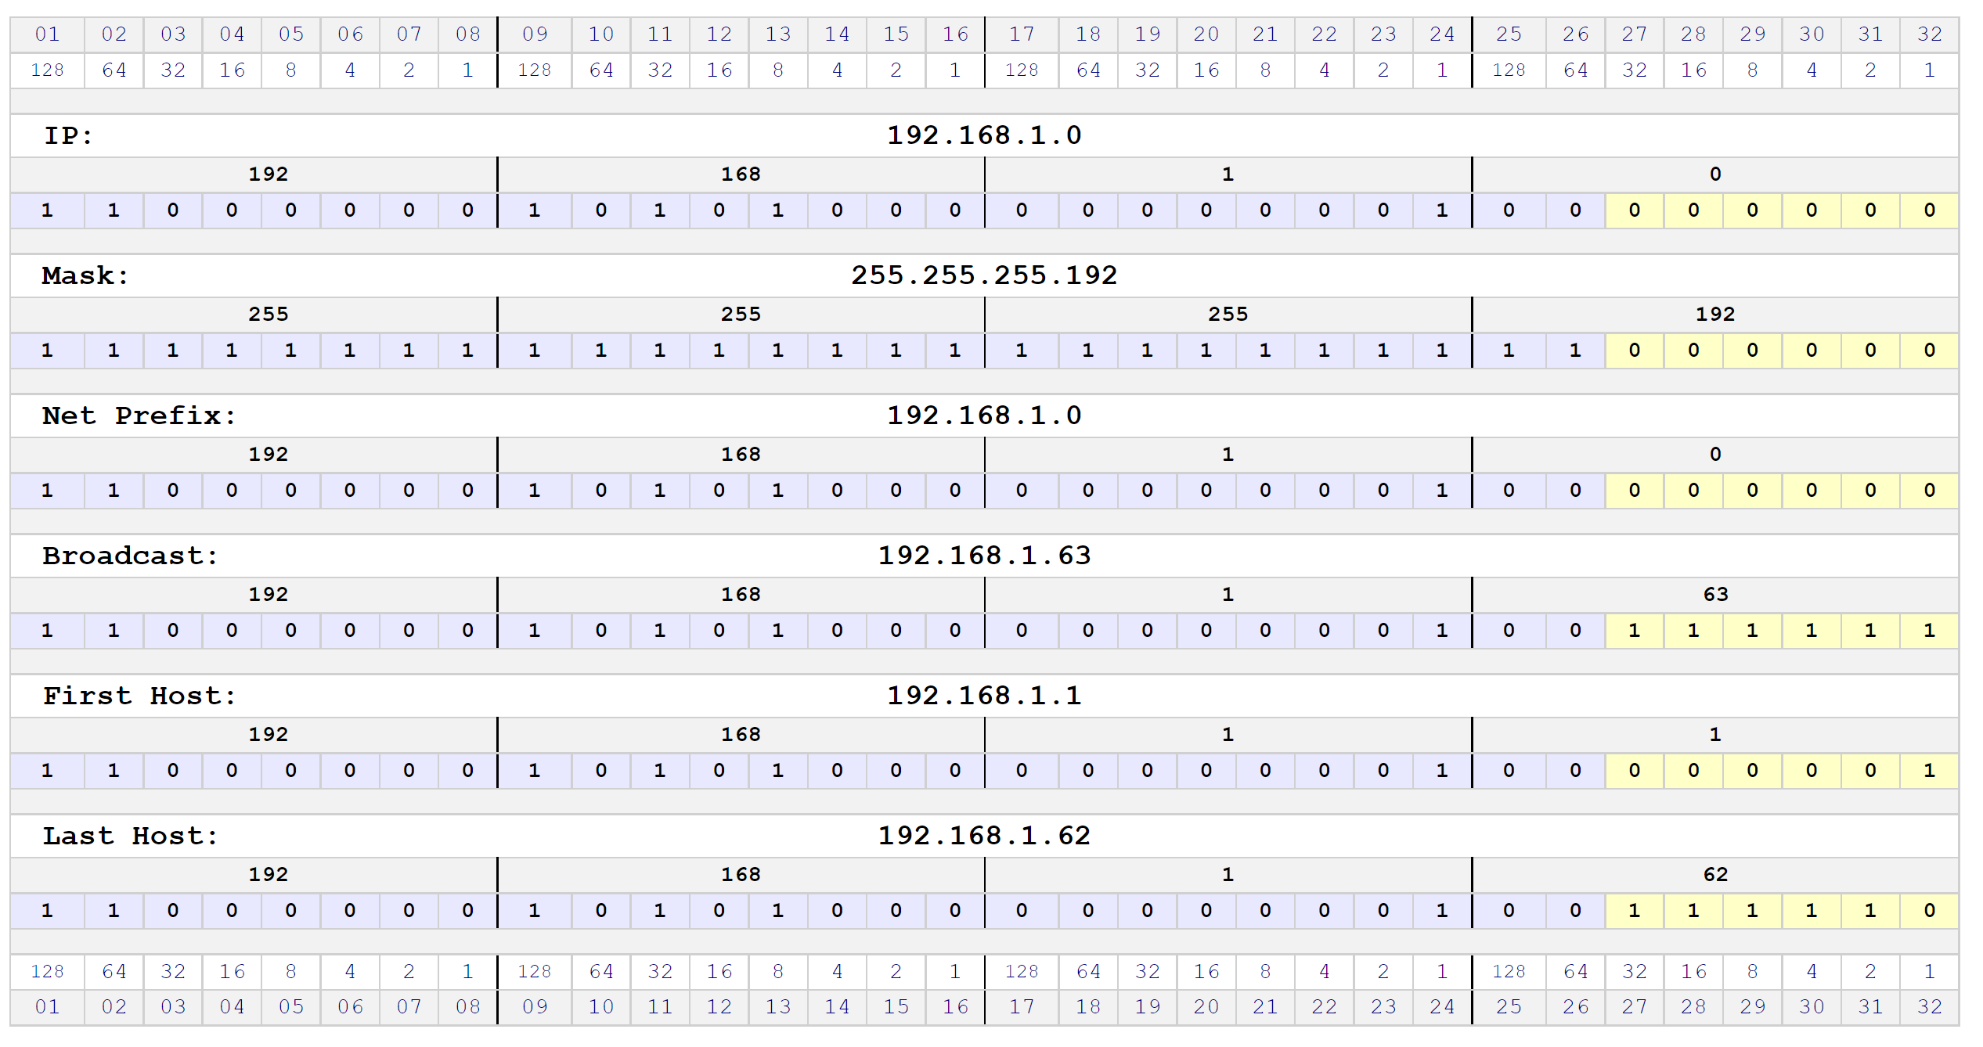

So by fixing 26 bit of an IP address we can search for 62 IP addresses.

1. Find the list of up servers and devices in the victim network.

First we can see the hosts which are up and running by running nmap -sp of the attacker VM address:

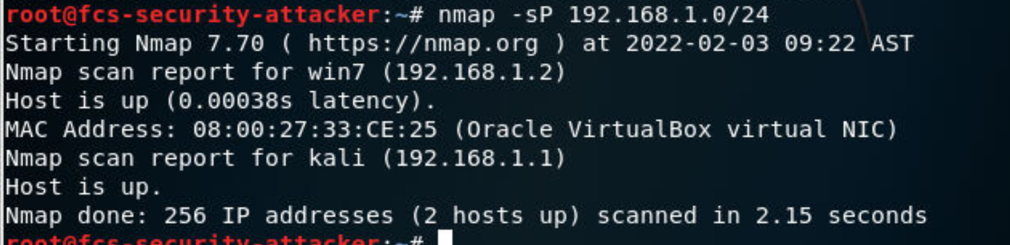

We see that 192.168.1.2 is up This is actually the IP address of the windows victim.

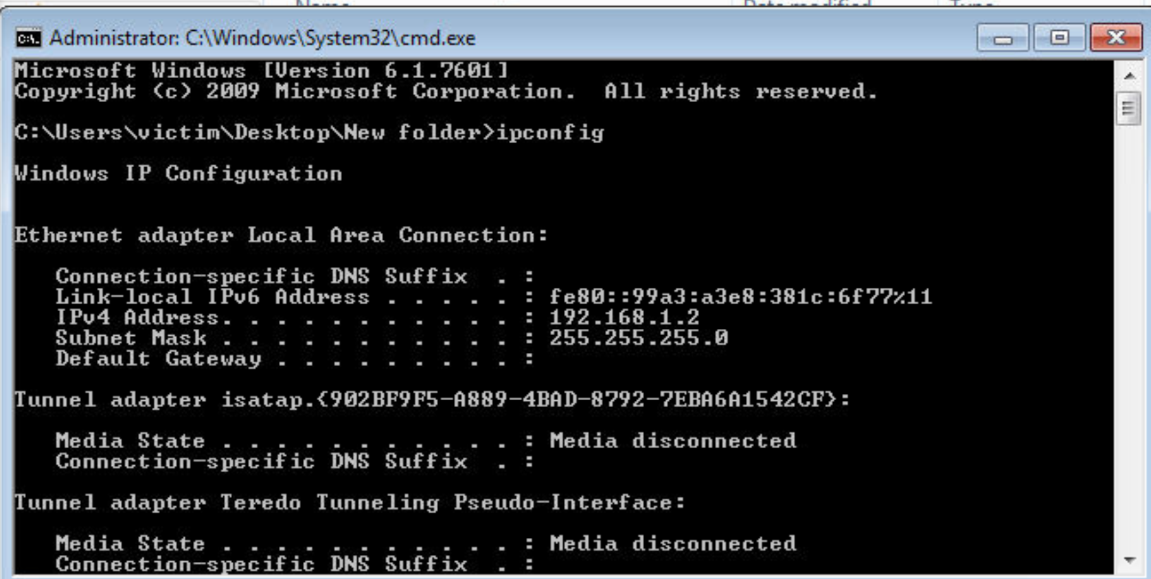

By running nmap for Windows Victim in attacker terminal we can see all the services that are up in victims machine

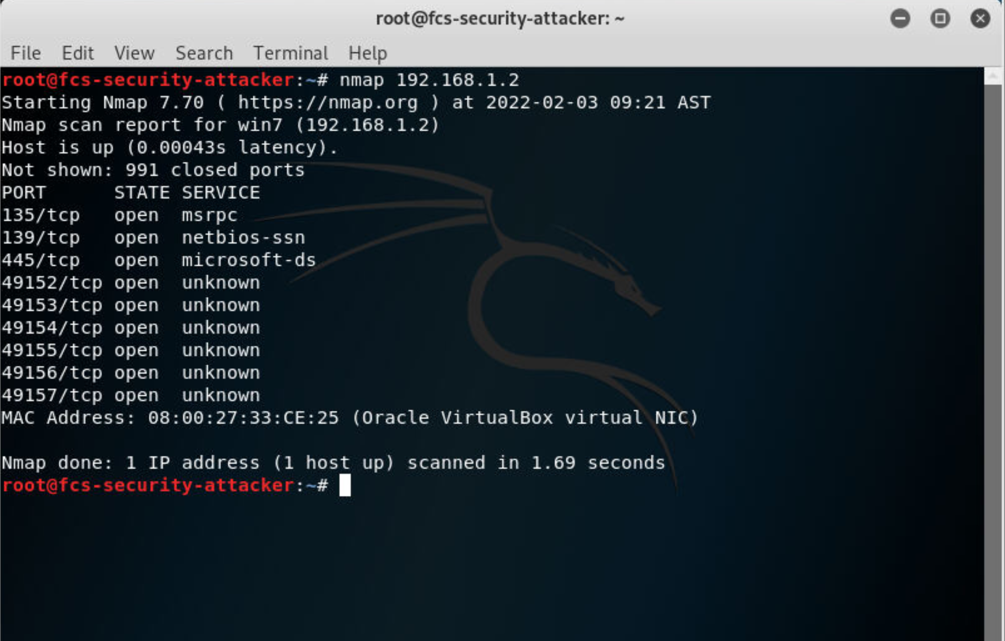

1. Find the OS of the first up computer in the victim network (from now this machine is your victim machine or target).



First Up Machine is Windows 192.168.1.2

Then by running nmap -o we can find the operating system of the victim

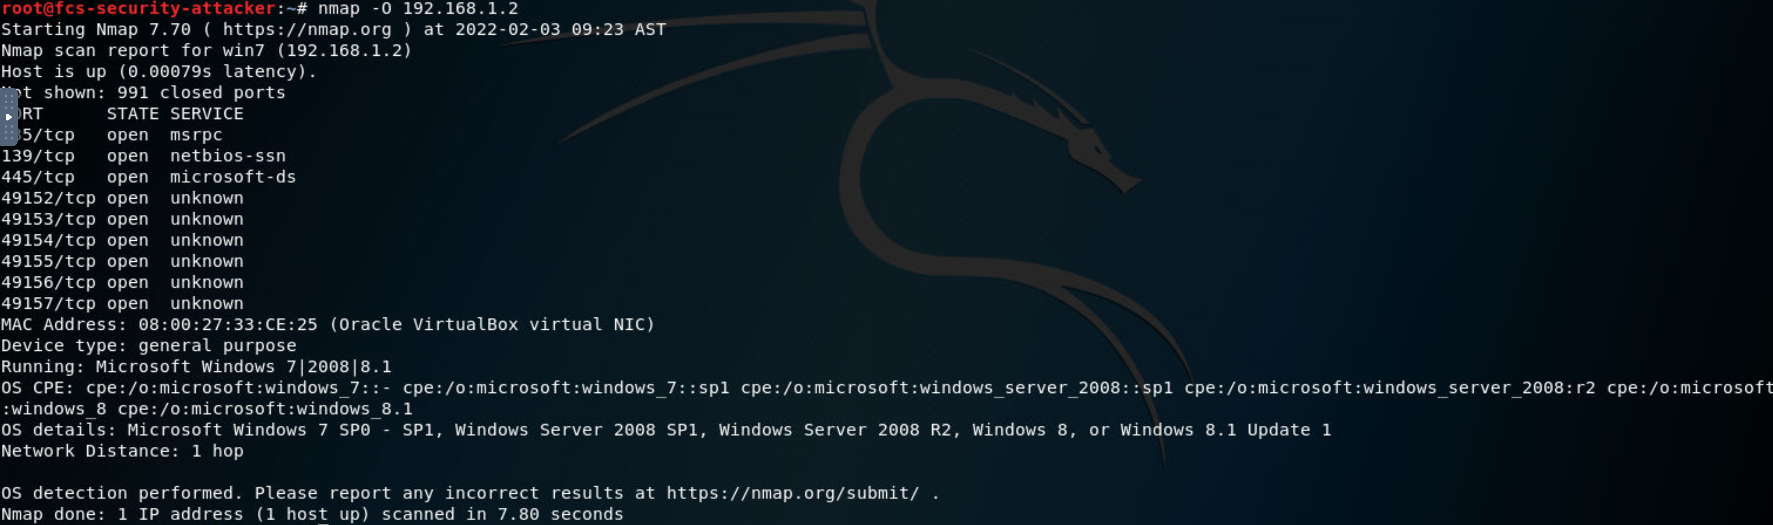

1. Find all open ports and the reason that are in the particular states on the victim machine

Using nmap -reason -open we can find all open ports and the reason of the open service

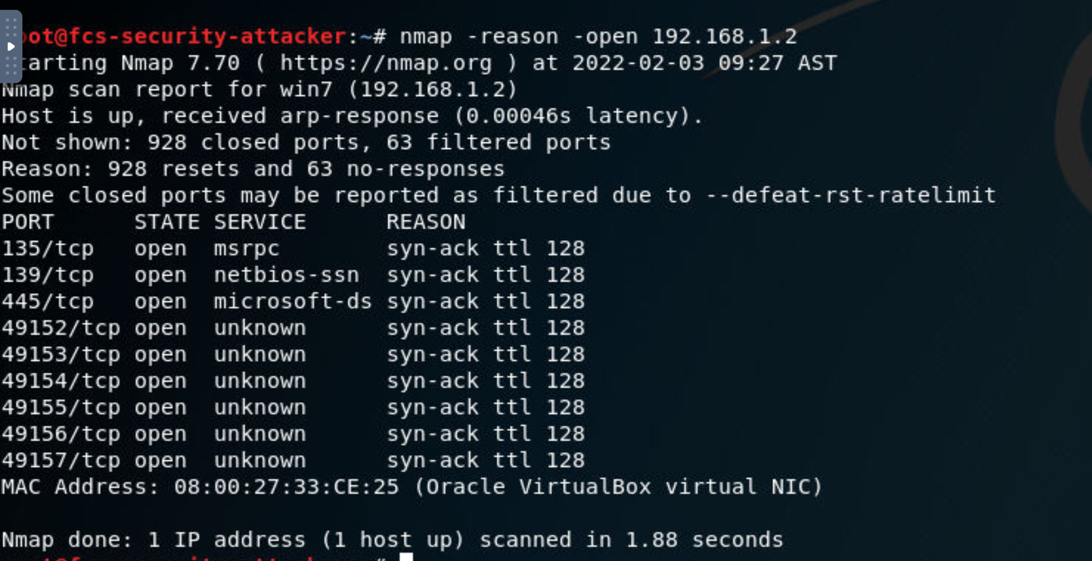

1. Find out if the host is protected by a firewall.

By using nmap -sA we can find if the targe machine is filtered or unfiltered (with firewall or without firewall)

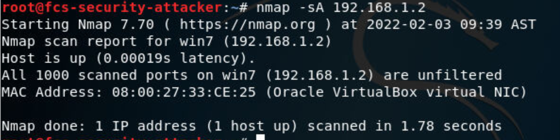

The firewall is off on Windows Victim

1. Find the common vulnerabilities on the victim machine.

By Using nmap -sV we can find all the vulnerabilities on Victim machine for each service

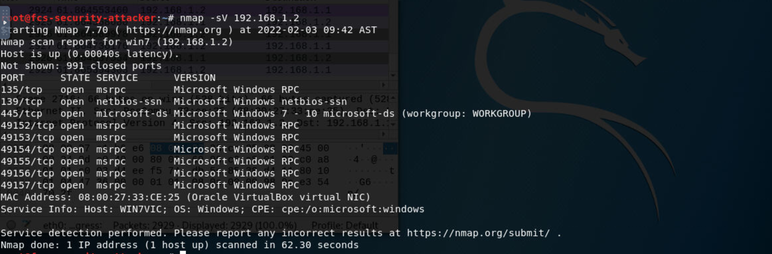

Captured Packets Available

Sample Packets are:

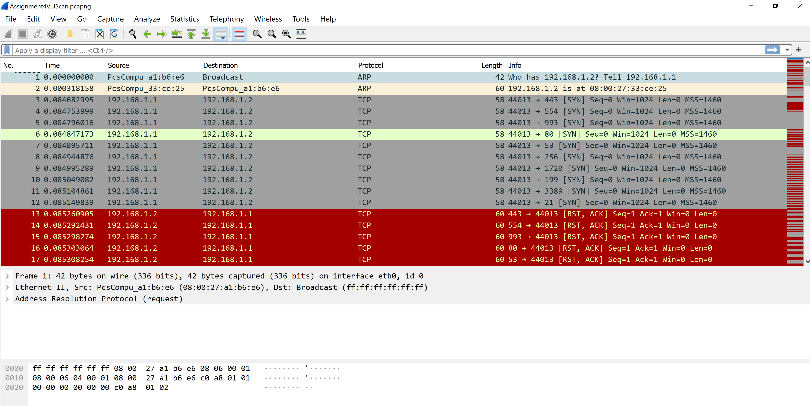

All the packets are available in the pcap attached file. The -sV tries to communicate to all ports of the victim machine to fin out the services and vulnerabilities. There are a lot of packets since in tries with many ports. Not all the ports are working so most of the communications didn’t get a respond and that’s why they are in red in pcap file.